**DAILY ONLINE ACTIVITIES SUMMARY**

|  |  |  |  |  |  |  |  |  |
| --- | --- | --- | --- | --- | --- | --- | --- | --- |
| **Date:** | **18-05-2020** | | | | | **Name:** | **Priyanka Killedar** | |
| **Sem & Sec** | **6th  Sem ‘B’ Sec** | | | | | **USN:** | **4AL17CS067** | |
| **Online Test Summary** | | | | | | | | |
| **Subject** | | **CNSC** | | | | | | |
| **Max. Marks** | | **60** | | **Score** | | | **43** | |
| **Certification Course Summary** | | | | | | | | |
| **Course** | **Machine Learning with Python** | | | | | | | |
| **Certificate Provider** | | | **IBM** | | **Duration** | | | **10 hr**  **Completed 2 hr** |
| **Coding Challenges** | | | | | | | | |
| **Problem Statement: 4 problems**  **2 programs solved using java and other 2 using C** | | | | | | | | |
| **Status: solved all the 4** | | | | | | | | |
| **Uploaded the report in Github** | | | | | **yes** | | | |
| **If yes Repository name** | | | | | <https://github.com/Priya-s-k/Online-coding-updates> | | | |
| **Uploaded the report in slack** | | | | | **yes** | | | |

**Online Test Details:** 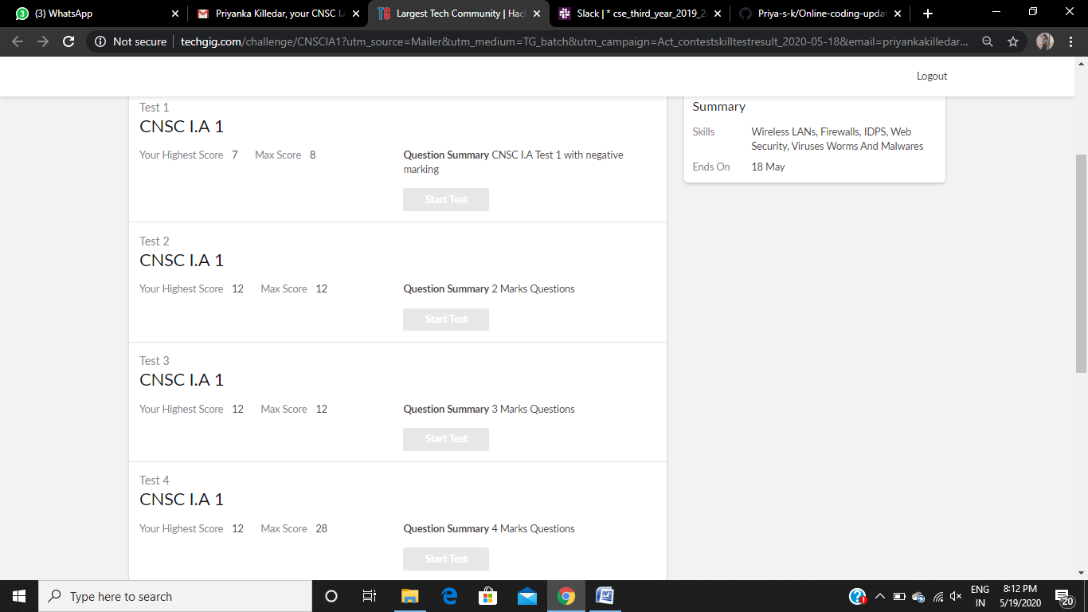

**Certification Course Details:**

Refer the github link for detail information : <https://github.com/Priya-s-k/Online-Certification-course-updates>

**Topics completed today:**

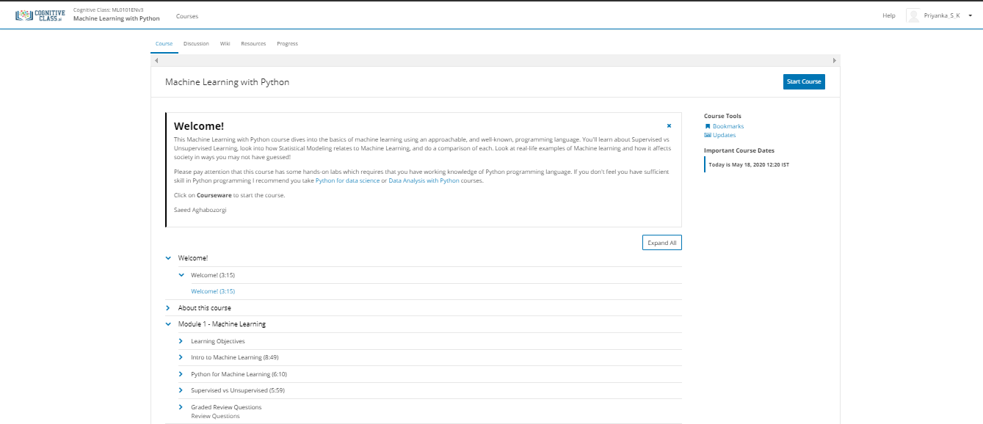

**Progress Report :**

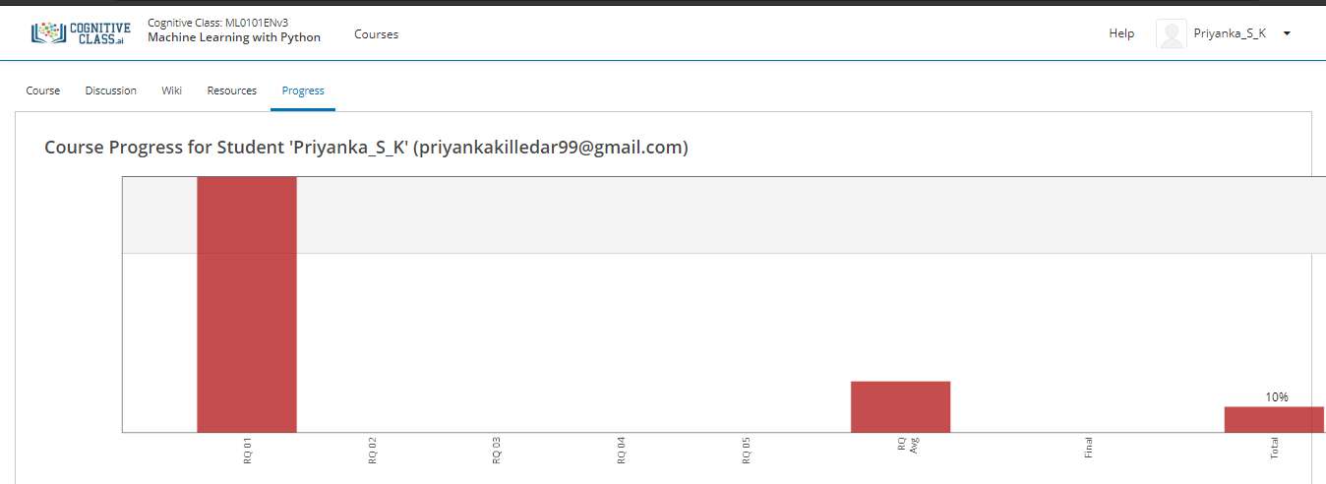

**Coding Challenges Details:**

Refer the github link for detail information :<https://github.com/Priya-s-k/Online-coding-updates>

Solved all the 4 problems and the solutions are uploaded in github account.

The same report is also available in github: <https://github.com/Priya-s-k/online-activity-updates>